

G.K.M COLLEGE OF ENGINEERING AND TECHNOLOGY
CHENNAI-600063
BIOMETRIC SECURITY SYSTEM FOR VOTING PLATFORM IN BLOCK CHAIN TECHNOLOGY
PROJECT REPORT
SUBMITTED BY
TEAM ID: NM2023TNID00528
TEAM MEMBERS:
1) L.VISHNU VARTHINI BAI - 410820121039
2) K.AARTHI - 410820121001
3) K.KAVIYA - 410820121022
4) P.SENKATHIR -410820121033

TABLE OF CONTENT
1. INTRODUCTION
1.1 Project Overview
1.2 Purpose
2. LITERATURE SURVEY
2.1 Existing problem
2.2 References
2.3 Problem Statement Definition
3. IDEATION & PROPOSED SOLUTION
3.1 Empathy Map Canvas
3.2 Ideation & Brainstorming
4. REQUIREMENT ANALYSIS
4.1 Functional requirement
4.2 Non-Functional requirements
5. PROJECT DESIGN
5.1 Data Flow Diagrams & User Stories
5.2 Solution Architecture
6. PROJECT PLANNING & SCHEDULING
6.1 Technical Architecture
6.2 Sprint Planning & Estimation
6.3 Sprint Delivery Schedule
7. CODING & SOLUTIONING
7.1 Feature1
7.2 Feature2
8. PERFORMANCE TESTING
8.1 Performance Metrics
9. RESULTS
9.1 Output Screenshots
10. ADVANTAGES & DISADVANTAGES
11. CONCLUSION
12. FUTURE SCOPE
13. APPENDIX
Source Code GitHub & Project Demo Link
CHAPTER - 1
- INTRODUCTION
Introducing a biometric security system for voting on the block chain represents a significant step towards enhancing the security, transparency, and trustworthiness of electoral processes. This innovative approach combines two crucial elements: biometrics and block chain technology. Biometric authentication uses unique physical or behavioral characteristics of individuals, such as fingerprints, iris scans, or facial recognition, to verify their identity. By integrating biometrics into the voting process, it becomes extremely difficult for unauthorized individuals to cast votes or commit voter fraud. This adds an extra layer of security to the system. Block chain is a decentralized and immutable ledger that records transactions in a secure and transparent manner. When applied to voting, it ensures that once a vote is cast, it cannot be altered or deleted, providing a tamper-resistant record of the election. Here's how a biometric security system for voting on the block chain works: Voter Registration: Voters' biometric data (e.g., fingerprints or facial scans) is collected and securely stored on the block chain. Each voter is assigned a unique digital identity. Voting Process: When a voter participates in an election, they are required to provide their biometric data for authentication. Once their identity is verified, they can cast their vote electronically through a secure app or website. Block chain Recording : Each vote is recorded as a transaction on the block chain. This transaction is time-stamped and linked to the voter's digital identity, ensuring transparency and accountability. Verification and Counting: Block chain's decentralized nature allows independent verification by multiple nodes, making it extremely difficult to manipulate the results. Votes can be counted automatically, and results are immediately available to the public.
1.1 PROJECT OVERVIEW
The "Biometric Voting System on Block chain" project aims to develop a secure and transparent voting system that utilizes biometric authentication and block chain technology to revolutionize the electoral process. This innovative system will ensure the integrity of votes, enhance security, and provide transparency for election procedures. Biometric Data Collection and Verification: Voter registration involves collecting biometric data, such as fingerprints, facial scans, or iris scans, from eligible voters. Verification of voters' identities is performed during the election process using biometric data. Block chain Integration: Utilize a block chain network to record and store votes securely and immutably. Deploy smart contracts to manage the voting process and validate the authenticity of voters. Voting Process: Voters can participate in elections through a secure mobile app or website. They must provide their biometric data for authentication. Once verified, voters can cast their votes electronically. Decentralized Validation: Employ multiple nodes in the block chain network for independent verification of votes. Enhance security by making it extremely difficult to manipulate the results. Results and Transparency: Automatically count and record votes on the block chain. Election results are immediately available for public scrutiny, providing transparency and trust in the process. Accessibility and Usability: Ensure the system is user-friendly and accessible to a wide range of voters. Implement security measures to protect voters' biometric data. Security Measures: Implement robust cyber security measures to protect against hacking and data breaches. Address privacy concerns related to biometric data and personal information.

1.2 PURPOSE
Using a biometric security system for voting on a block chain serves several purposes:
- Identity Verification: Biometrics, like fingerprints or facial recognition, can help ensure that voters are who they claim to be, reducing the risk of impersonation.
- Tamper Resistance: Block chain technology provides a tamper-resistant ledger for recording votes. Once a vote is recorded, it's extremely difficult to alter or delete.
- Transparency: The block chain's decentralized nature allows for transparency in the voting process. Anyone can audit the results and verify the integrity of the system.
- Security: Biometric data can enhance security, making it difficult for unauthorized individuals to cast votes.
- Accessibility: Biometrics can make voting more accessible for individuals with disabilities or those who may struggle with traditional paper-based or electronic voting methods.
- Remote Voting: Block chain can enable secure remote voting, which is especially relevant during events like pandemics when physical polling places may pose health risks.
- Reducing Fraud: Combining biometrics with block chain can reduce voter fraud and ensure the integrity of the electoral process.
CHAPTER - 2
- LITERATURE SURVEY
A literature survey on the use of biometric security systems for voting in block chain technology is a comprehensive and valuable research topic. It involves examining existing academic papers, articles, and publications on this subject. You would typically want to investigate the following aspects:
- Biometric Authentication in Voting: Explore how biometric authentication methods such as fingerprint recognition, iris scanning, or facial recognition can be integrated into the voting process to enhance security and identity verification.
- Block chain Technology: Understand the principles and applications of block chain in voting systems. How can block chain provide transparency, immutability, and security in the context of voting?
- Security and Privacy: Investigate the security and privacy implications of using biometrics and block chain for voting. How can these technologies protect against fraud and maintain the anonymity of voters?
- Case Studies and Implementations: Look for real-world case studies or prototypes that have implemented biometric-based voting on block chain. Examine their strengths and weaknesses.
- Challenges and Concerns: Identify any challenges or concerns associated with implementing such a system. These might include legal, ethical, or technical issues.
- Future Directions: Explore potential areas for future research and development in this field. What are the emerging trends, and how can these systems be improved?
Remember to search academic databases, journals, and conferences for relevant papers and keep your survey up to date with the latest research in the field.

2.1 EXISTING PROBLEM
Implementing a biometric security system for voting on the block chain presents several challenges and potential problems:
- Privacy Concerns: Storing biometric data on a block chain could raise significant privacy concerns, as this data is highly sensitive and immutable. Protecting individuals' privacy while ensuring the security of the block chain is a delicate balance.
- Accuracy and Reliability: Biometric systems must be highly accurate and reliable to prevent fraud. Ensuring that biometric data is captured and verified correctly is essential, as false positives and false negatives can disenfranchise voters.
- Identity Theft: Storing biometric data on a block chain could make individuals more vulnerable to identity theft if the block chain's security is compromised. Once biometric data is on the block chain, it's challenging to revoke or change.
- Scalability: Handling a large number of biometric verifications in real-time, especially during peak voting periods, can be challenging for a block chain system. Scalability issues may result in slow processing times or network congestion.
- Inclusivity: Biometric systems may not be accessible to everyone, as not all individuals have usable biometric markers (e.g., fingerprint or iris). Ensuring inclusivity for all eligible voters is essential.
- Biometric Data Protection: Storing biometric data securely is critical. Even if it's hashed or encrypted, the storage and retrieval mechanisms must be robust to prevent data breaches.
- Block chain Security: The security of the block chain itself is crucial. If the underlying block chain technology is vulnerable, it can undermine the entire voting system, making it susceptible to manipulation or fraud.
- Legal and Regulatory Challenges: Different regions have various regulations regarding the use of biometric data. Adhering to these regulations and ensuring compliance can be a complex legal challenge.
- Voter Authentication: Verifying that the person presenting the biometric data is indeed the eligible voter is a challenge. Additional identity verification methods may be necessary.
- Recovery and Revocation: Enabling recovery or revocation of biometric data in case of compromise or changes in an individual's biometric markers is a complex problem.
2.2 REFERENCE
Implementing a biometric security system for voting on a block chain can enhance the security and integrity of the voting process. Here's a high-level overview of how this can be done:
- Voter Registration: Voters need to register in the block chain-based system with their biometric data (e.g., fingerprints, retina scans, facial recognition).
- Biometric Data Storage: Store the biometric data in a secure and decentralized manner on the block chain, ensuring that it's tamper-proof and private.
- Voter Verification: During the voting process, voters provide their biometric data for verification.
- Biometric Matching: The system matches the provided biometric data with the registered data on the block chain to verify the voter's identity.
- Vote Submission: Once the voter's identity is confirmed, they can cast their vote securely.
- Block chain Consensus: The vote is recorded as a transaction on the block chain, benefiting from the block chain's security and transparency.
- Privacy Considerations: Ensure that the biometric data is stored in a way that protects voters' privacy. This may involve using cryptographic techniques to keep the data confidential.
- Accessibility and Inclusivity: Consider the need for alternative methods for voters who may not have biometric data or have difficulty with biometric verification.
- Security Measures: Implement additional security measures to protect against identity theft and fraud, such as multi-factor authentication and encryption.
- Independent Verification: Allow for independent auditing and verification of the block chain voting system to ensure its integrity.
It's important to keep in mind that implementing a secure and reliable block chain-based voting system with biometric security is a complex task. It requires a robust infrastructure, careful consideration of privacy and security concerns, and a way to ensure inclusivity for all eligible voters. Additionally, the legal and regulatory aspects of such a system must be thoroughly addressed to ensure compliance with local and national voting laws.
2.3 PROBLEM STATEMENT DEFINITION
The traditional voting system faces numerous challenges, including security concerns, lack of transparency, and potential voter fraud. To address these issues, a biometric security system for voting on a block chain is proposed. The goal is to create a secure, transparent, and tamper-proof voting system that leverages block chain technology and biometric authentication to ensure the integrity of the electoral process.
Key Objectives:
- Secure Voting: Develop a system that prevents unauthorized access and ensures the confidentiality and integrity of votes.
- Transparency: Implement a transparent system where every voter can verify that their vote has been recorded and counted correctly.
- Authentication: Utilize biometric data (such as fingerprints, iris scans, or facial recognition) to verify the identity of voters, reducing the risk of impersonation.
- Immutable Record: Create an immutable record of votes on a block chain to prevent data manipulation or tampering.
- Accessibility: Ensure that the system is user-friendly and accessible to all eligible voters, including those with disabilities.
- Scalability: Design a system capable of handling a large number of voters during elections of various scales.
- Privacy: Protect the privacy of voters by anonymizing their identity while ensuring the security of their votes.
- Resilience: Establish safeguards against system failures, cyber attacks, and data breaches.
- Compliance: Ensure compliance with legal and regulatory requirements for elections and data protection.
- Usability: Create an intuitive and efficient user interface for both voters and election administrators.
This project aims to revolutionize the electoral process by combining the security of block chain technology with the reliability of biometric authentication, making voting more accessible, transparent, and secure.

CHAPTER-3
- IDEATION & PROPOSED SOLUTION
Using a biometric security system for voting on a block chain is an interesting idea that could enhance the security and transparency of elections. Here are some key points to consider when brainstorming this concept:
Biometric Verification: Implement biometric authentication methods like fingerprint or iris scans to verify the identity of voters. This would ensure that only eligible voters can participate.
- Block chain Technology: Utilize block chain for recording and storing votes. This ensures transparency, immutability, and a tamper-proof ledger.
- Smart Contracts: Smart contracts can be used to automate the voting process, ensuring that once a vote is cast, it's recorded and cannot be altered.
- Privacy: Ensure that the system protects voter privacy. Biometric data should be securely stored, and the block chain should only record anonymized votes to prevent the identification of individual voters.
- Decentralization: Use a decentralized block chain network to prevent central authority control over the voting process.
- Accessibility: Make the system user-friendly and accessible to all, including those who might not have access to biometric technology.
- Security Audits: Regularly conduct security audits and testing to identify and address vulnerabilities.
- Voter Education: Educate voters on how to use the system and the benefits of block chain-based voting.
- Backup Mechanisms: Consider backup mechanisms in case of technical failures or unforeseen issues.
- Legal and Regulatory Compliance: Ensure the system complies with relevant laws and regulations, especially regarding data protection and election integrity.
- Testing and Pilots: Start with small-scale testing or pilot programs to work out any issues before full-scale implementation.
- Open Source Development: Consider open-source development to allow for public scrutiny and contributions.
- Keep in mind that implementing a biometric block chain voting system would require a comprehensive and collaborative effort involving experts in block chain technology, security, and election administration. It's crucial to address technical, ethical, and legal challenges to make this concept a reality.
3.1 EMPATHY MAP CANVAS
Using a biometric security system for voting on a block chain is an interesting idea that could enhance the security and transparency of elections. Here are some key points to consider when brainstorming this concept:
- Biometric Verification: Implement biometric authentication methods like fingerprint or iris scans to verify the identity of voters. This would ensure that only eligible voters can participate.
- Block chain Technology: Utilize block chain for recording and storing votes. This ensures transparency, immutability, and a tamper-proof ledger.
- Smart Contracts: Smart contracts can be used to automate the voting process, ensuring that once a vote is cast, it's recorded and cannot be altered.
- Privacy: Ensure that the system protects voter privacy. Biometric data should be securely stored, and the block chain should only record anonymized votes to prevent the identification of individual voters.
- Decentralization: Use a decentralized block chain network to prevent central authority control over the voting process.
- Accessibility: Make the system user-friendly and accessible to all, including those who might not have access to biometric technology.
- Security Audits: Regularly conduct security audits and testing to identify and address vulnerabilities.
- Voter Education: Educate voters on how to use the system and the benefits of block chain-based voting.
- Backup Mechanisms: Consider backup mechanisms in case of technical failures or unforeseen issues.
- Legal and Regulatory Compliance: Ensure the system complies with relevant laws and regulations, especially regarding data protection and election integrity.
- Testing and Pilots: Start with small-scale testing or pilot programs to work out any issues before full-scale implementation.
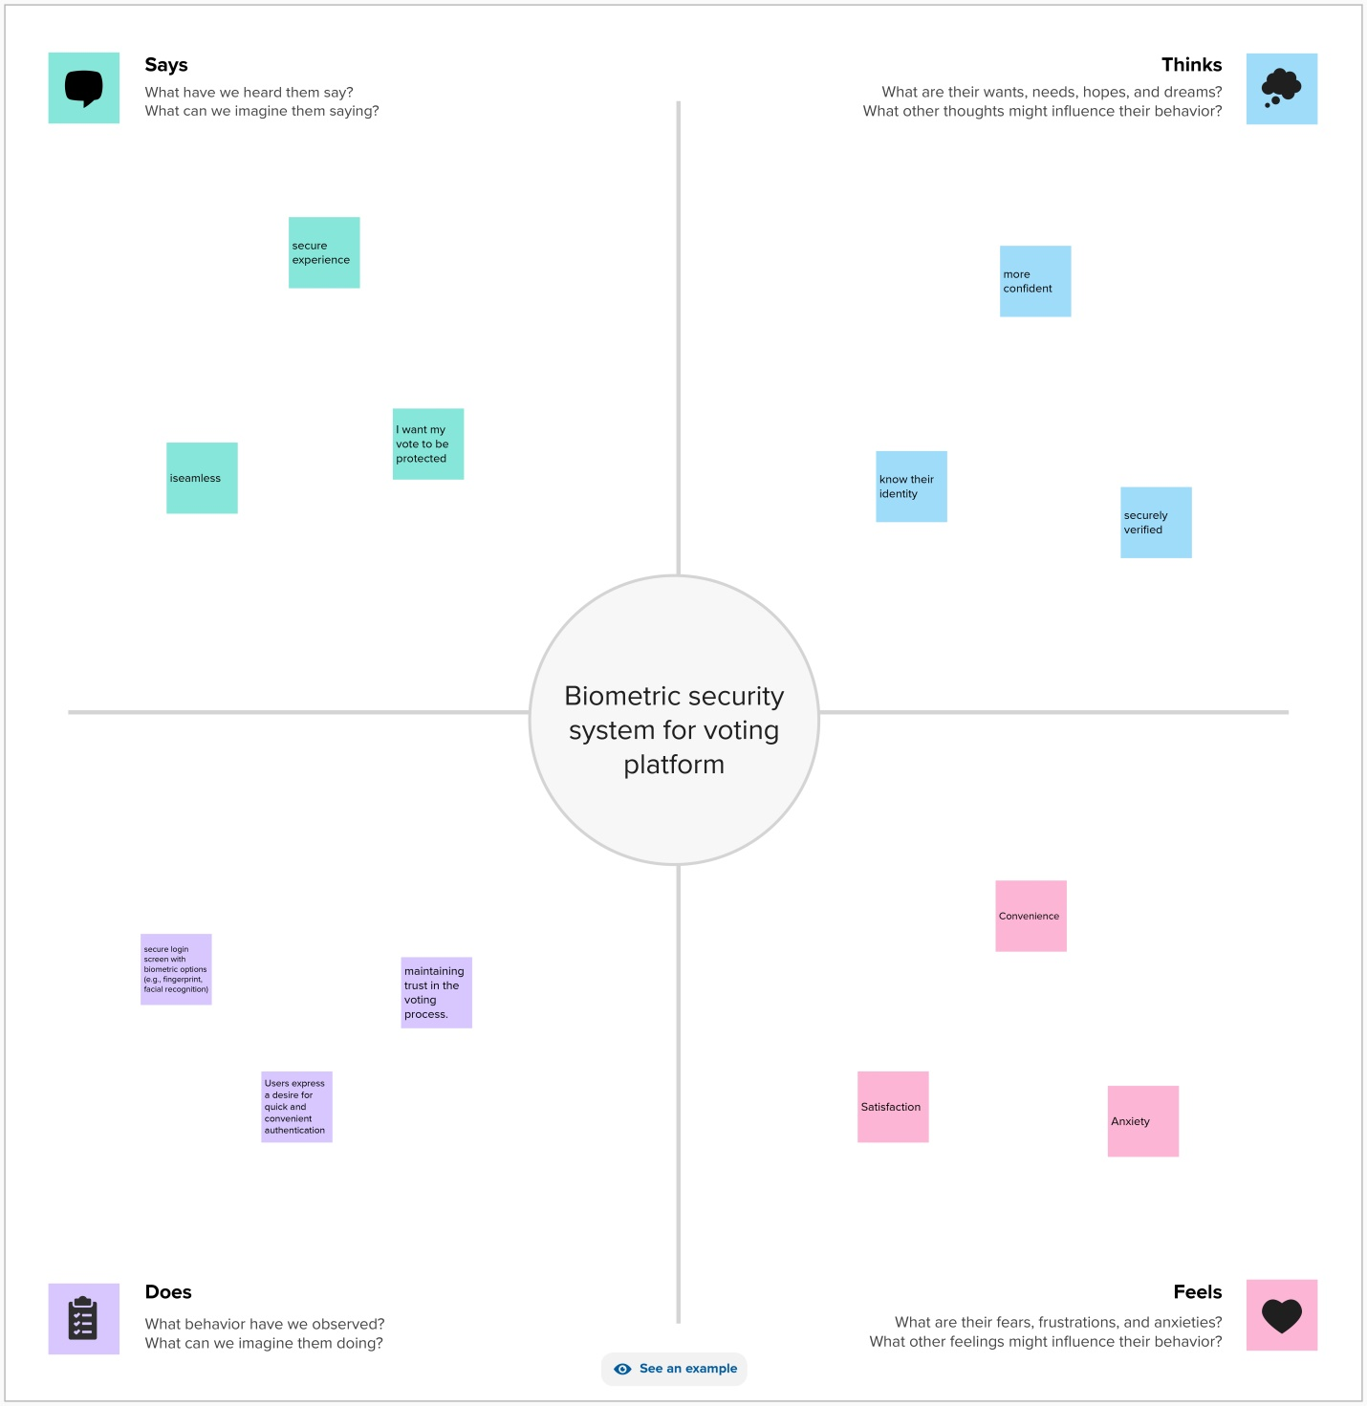

3.2 IDEATION & BRAINSTORMING
Using a biometric security system for voting on a block chain is an interesting idea that could enhance the security and transparency of elections. Here are some key points to consider when brainstorming this concept:
- Biometric Verification: Implement biometric authentication methods like fingerprint or iris scans to verify the identity of voters. This would ensure that only eligible voters can participate.
- Block chain Technology: Utilize block chain for recording and storing votes. This ensures transparency, immutability, and a tamper-proof ledger.
- Smart Contracts: Smart contracts can be used to automate the voting process, ensuring that once a vote is cast, it's recorded and cannot be altered.
- Privacy: Ensure that the system protects voter privacy. Biometric data should be securely stored, and the block chain should only record anonymized votes to prevent the identification of individual voters.
- Decentralization: Use a decentralized block chain network to prevent central authority control over the voting process.
- Accessibility: Make the system user-friendly and accessible to all, including those who might not have access to biometric technology.
- Security Audits: Regularly conduct security audits and testing to identify and address vulnerabilities.
- Voter Education: Educate voters on how to use the system and the benefits of block chain-based voting.
- Backup Mechanisms: Consider backup mechanisms in case of technical failures or unforeseen issues.
- Legal and Regulatory Compliance: Ensure the system complies with relevant laws and regulations, especially regarding data protection and election integrity.
- Testing and Pilots: Start with small-scale testing or pilot programs to work out any issues before full-scale implementation.
- Open Source Development: Consider open-source development to allow for public scrutiny and contributions.
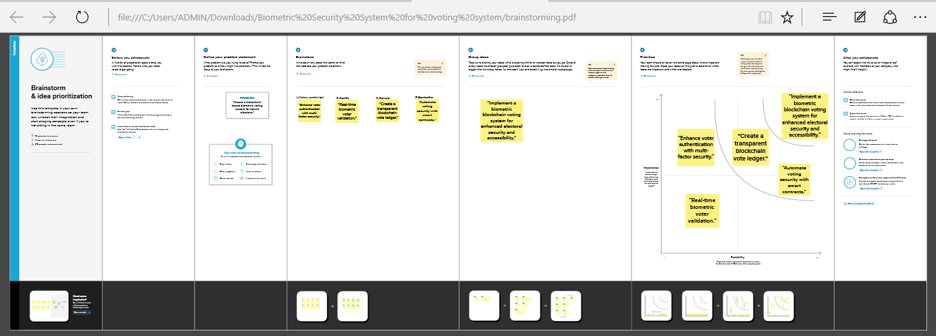
CHAPTER- 4
- REQUIREMENT ANALYSIS
4.1 FUNCTIONAL REQUIREMENTS
A biometric security system for voting on the block chain would need to meet several functional requirements to ensure the integrity and security of the voting process. Here are some key functional requirements:
- Voter Registration: Securely collect and store biometric data (e.g., fingerprints, iris scans) from eligible voters during the registration process. Verify the identity of voters through biometric authentication.
- Block chain Integration: Utilize a block chain platform to record and store votes securely and immutably. Implement smart contracts for managing the voting process, ensuring transparency and tamper resistance.
- Voter Privacy: Guarantee the privacy of the voters by anonymizing their biometric data and votes on the block chain. Implement zero-knowledge proofs or similar cryptographic techniques to maintain anonymity.
- Voter Authentication: Implement a secure and reliable biometric authentication system to confirm the identity of voters before allowing them to cast their votes.
- Data Security: Encrypt and protect biometric data and voting records from unauthorized access. Use robust encryption algorithms and cyber security practices to safeguard data.
- Double Voting Prevention: Ensure that each voter can cast only one vote, preventing double voting. Implement mechanisms to detect and prevent fraudulent activities.
- User-Friendly Interface: Develop an intuitive and accessible user interface for voters to participate easily. Make the system accessible to individuals with disabilities.
- Auditability: Provide tools for voters and relevant authorities to independently verify the voting process and results recorded on the block chain.
- Resilience and Redundancy: Ensure system availability and reliability through backup mechanisms and redundancy. Be prepared to handle unexpected events or attacks.
- Open Source and Transparency: Use open-source software and publish the code for public scrutiny. Ensure transparency in the design, development, and operation of the system.
- Regulatory Compliance: Comply with legal and regulatory requirements related to voting and data protection. Be prepared to adapt to changing regulations.
- Testing and Validation: Conduct rigorous testing, including penetration testing, to identify and rectify vulnerabilities. Validate the accuracy and security of the biometric authentication system.
- Decentralization: Consider a decentralized architecture to distribute the responsibility of verifying and recording votes to prevent single points of failure.

4.2 NON- FUNCTIONAL REQUIREMENTS
Non-functional requirements for a biometric security system in a block chain-based voting system are critical to ensuring its reliability, security, and performance. Here are some non-functional requirements to consider:
Security:
- Authentication: The system should ensure that only authorized voters can participate by securely verifying their biometric data.
- Data Encryption: All data, including biometric information, should be encrypted to protect it from unauthorized access.
- Integrity: Data stored on the block chain should remain tamper-proof to maintain the integrity of the voting process.
- Resilience: The system should be resilient to various forms of attacks, such as DDoS attacks, to ensure the availability of the voting service.
- Scalability: The system should be able to handle a large number of voters and transactions as voting events can have varying levels of participation.
- Performance: Response Time: The system should have low-latency response times to ensure a smooth and efficient voting process.
- Throughput: It should be able to handle a high volume of transactions simultaneously.
- Reliability: The system should be highly reliable, ensuring that votes are accurately recorded and securely stored on the block chain.
- Privacy: Protecting the privacy of voters is crucial. The system should ensure that individual votes cannot be linked back to voters.
- Compliance: Ensure compliance with legal and regulatory requirements for voting systems, including GDPR, if applicable.
- Usability: The system should be user-friendly, allowing voters to easily interact with it, even if they have little technical expertise.
- Interoperability: The system should be able to work seamlessly with different biometric devices and platforms to accommodate a variety of voter devices.
- Auditability: The block chain should allow for transparent and auditable access to the voting records, while still protecting the privacy of voters.
- Redundancy and Disaster Recovery: The system should have redundancy in place to ensure voting can continue in the event of system failures or disasters.
- Maintenance and Support: There should be plans for ongoing maintenance, updates, and support to keep the system operational and secure.
- Cost-Efficiency: The system should be cost-effective to implement and maintain to ensure it is accessible to a broad range of voting organizations.
- Immutable Records: Ensure that once a vote is recorded on the block chain, it cannot be altered or deleted, preserving the verifiability of the voting process.
- Cross-Device Compatibility: The biometric system should work across different devices, including smartphones, tablets, and desktop computers.
These non-functional requirements are essential for building a secure and reliable biometric-based voting system on a block chain. They help ensure the integrity of the voting process, protect voter privacy, and maintain the system's performance and availability.
CHAPTER-5
5. PROJECT DESIGN
5.1 DATA FLOW DIAGRAMS & USER STORIES
1. Voter Registration:
- Collect biometric data (fingerprint, facial recognition, etc.) during voter registration.
- Store this data securely on the block chain, possibly using a decentralized identity system.
2. Voter Authentication:
- During the voting process, voters must be authenticated using their biometric data.
- Use biometric sensors or cameras to capture and verify the voter's identity.
- Ensure secure transmission of biometric data to prevent interception.
3. Biometric Data Storage:
- Store biometric templates or hashes on the block chain rather than raw biometric data for security and privacy reasons.
- Use encryption and hashing techniques to protect the stored data.
4.Voting Process:
- Voters' biometric data is matched with their stored templates on the block chain.
- If a match is confirmed, the voter can proceed with casting their vote.
5. Data Integrity:
- Ensure the integrity of the voting data on the block chain using cryptographic techniques like digital signatures.
6. Privacy Protection:
- Implement techniques like zero-knowledge proofs to protect voter privacy, ensuring that the voter's biometric data doesn't need to be disclosed during the voting process.
7. Decentralization:
- Use a decentralized block chain network to prevent a single point of failure.
- Implement consensus mechanisms to validate and record votes.
8. Auditability:
- Make the entire voting process transparent and auditable by allowing anyone to verify the results on the block chain.
9. Security Measures:
- Protect against various attacks, including denial of service (DoS) attacks, Sybil attacks, and fraud attempts.
10. Testing and Certification:
- Thoroughly test the biometric system for vulnerabilities and accuracy.
- Seek certification or independent verification to ensure the system's reliability.
11. Legal and Ethical Considerations:
- Comply with data protection laws and ethical considerations related to biometric data.
12. Usability:
- Ensure that the biometric system is user-friendly and accessible to all eligible voters.
- Keep in mind that biometric systems can raise privacy concerns, and it's essential to strike a balance between security and privacy. Regular security assessments and updates are crucial to maintain the system's integrity and trustworthiness. Additionally, the block chain technology used for the project, whether it's a public or private block chain, will have implications for governance and security.

CHAPTER-6
6. PROJECT PLANNING AND SCHEDULING
6.1 TECHNICAL ARCHITECTURE


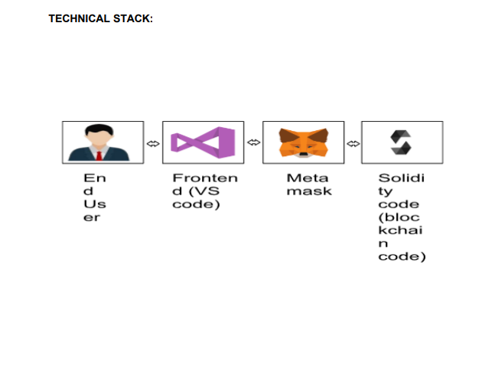
CHAPTER-7
7. CODING AND SOLUTION
// SPDX-License-Identifier: MIT
pragma solidity ^0.8.0;

contract BallotBox {
// Define the owner of the contract (election authority).
address public owner;

// Define the structure of a voter.
struct Voter {
bytes32 biometricData; // Encrypted biometric data
bool hasVoted; // Indicates if the voter has cast a vote
}

// Define the structure of a candidate.
struct Candidate {
string name;
uint256 voteCount;
}

// Define the election parameters.
string public electionName;
uint256 public registrationDeadline;
uint256 public votingDeadline;

// Store the list of candidates.
Candidate[] public candidates;

// Store the mapping of voters.
mapping(address => Voter) public voters;

// Event to announce when a vote is cast.
event VoteCast(address indexed voter, uint256 candidateIndex);

// Modifiers for access control.
modifier onlyOwner() {
require(msg.sender == owner, "Only the owner can call this function.");
_;
}

modifier canVote() {
require(block.timestamp < votingDeadline, "Voting has ended.");
require(block.timestamp < registrationDeadline, "Registration has ended.");
require(!voters[msg.sender].hasVoted, "You have already voted.");
_;
}

// Constructor to initialize the contract.
constructor(
string memory _electionName,
uint256 _registrationDeadline,
uint256 _votingDeadline,
string[] memory _candidateNames
) {
owner = msg.sender;
electionName = _electionName;
registrationDeadline = _registrationDeadline;
votingDeadline = _votingDeadline;

// Initialize the list of candidates.
for (uint256 i = 0; i < _candidateNames.length; i++) {
candidates.push(Candidate({
name: _candidateNames[i],
voteCount: 0
}));
}
}

// Function to register a voter and store their encrypted biometric data.
function registerVoter(bytes32 _encryptedBiometricData) public canVote {
voters[msg.sender] = Voter({
biometricData: _encryptedBiometricData,
hasVoted: false
});
}

// Function to cast a vote for a candidate.
function castVote(uint256 _candidateIndex) public canVote {
require(_candidateIndex < candidates.length, "Invalid candidate index.");
require(voters[msg.sender].biometricData != 0, "You must register first.");

// Mark the voter as having voted.
voters[msg.sender].hasVoted = true;

// Increment the candidate's vote count.
candidates[_candidateIndex].voteCount++;

// Emit a VoteCast event.
emit VoteCast(msg.sender, _candidateIndex);
}
}

CHAPTER-10
10. ADVANTAGES AND DISADVANTAGES
Advantages:
1. Enhanced Security: Biometric data, such as fingerprints or iris scans, is unique to each individual, making it difficult for unauthorized persons to impersonate someone else.
2. Reduced Voter Fraud: Biometrics can help reduce voter fraud by ensuring that only eligible voters can cast their ballots, minimizing the risk of double voting or voter impersonation.
3. Convenience: Biometric authentication can streamline the voting process by eliminating the need for physical identification documents, potentially making it more convenient for voters.
4. Accuracy: Biometric systems are generally accurate in verifying an individual's identity, reducing errors associated with manual verification.
5. Deterrent for Coercion: Biometrics can serve as a deterrent for voter coercion since it's harder for someone to force another person to vote a certain way when their biometric data is required.
Disadvantages:
1. Privacy Concerns: Storing biometric data can raise privacy concerns, as it's sensitive information that, if mishandled, could lead to identity theft or other privacy breaches.
2. Technical Challenges: Biometric systems can be vulnerable to technical issues, such as false positives or negatives, potentially disenfranchising eligible voters or allowing unauthorized individuals to vote.
3. Cost: Implementing a robust biometric voting system can be expensive, including the cost of collecting and securely storing biometric data and maintaining the necessary hardware and software.
4. Voter Exclusion: Some individuals may not have biometric data that is easily captured or reliable for authentication, potentially excluding them from the voting process.
5. Security Risks: While biometrics can enhance security, they are not foolproof, and if a database of biometric data is compromised, it could lead to significant security risks.
6. Complexity: Biometric systems can be more complex to implement and maintain than traditional voter identification methods.
7. Legal and Ethical Concerns: The use of biometrics for voting may raise legal and ethical questions, such as who has access to the data and under what circumstances it can be used.
CHAPTER-11
11. CONCLUSION
In conclusion, implementing a biometric security system for a voting system offers the potential for increased security, reduced voter fraud, and enhanced accuracy in verifying voter identities.
This technology can also provide a level of convenience for voters. However, it comes with significant challenges, including privacy concerns, technical issues, high costs, potential voter exclusion, and legal and ethical questions. Before adopting biometric solutions for voting systems, policymakers and election authorities must carefully weigh the benefits against the drawbacks and address these challenges to ensure a fair and secure electoral process. Additionally, it's crucial to maintain transparency, protect biometric data, and consider alternative methods to provide accessible and secure voting for all eligible citizens.

CHAPTER-12
12. FUTURE SCOPE
- Enhanced Security: Biometric authentication will continue to be a robust tool for enhancing the security of voting systems, reducing the risk of voter fraud, impersonation, and tampering.
- Technological Advancements: Advancements in biometric technology, such as improved accuracy, faster recognition, and more reliable data storage, will make biometrics even more effective for voter verification.
- Accessibility: Future biometric systems may be designed to ensure that individuals with various physical abilities can participate in the voting process. This could include accommodating individuals with disabilities or those who lack certain biometric traits.
- Privacy Measures: Addressing privacy concerns will be crucial. Future systems should incorporate strong privacy safeguards, data encryption, and secure storage to protect voters' sensitive information.
- Multimodal Biometrics: Using multiple biometric methods, such as combining fingerprints with facial recognition or iris scans, can improve accuracy and reliability, reducing the chances of false positives or negatives.
- Remote Voting: Biometric authentication could facilitate secure remote voting, allowing citizens to vote from their homes or other remote locations, which could increase voter turnout.
- Block chain Technology: Integrating biometric authentication with block chain technology can provide a tamper-proof and transparent voting process, ensuring the integrity of the results.
- Global Adoption: Biometric voting systems may become more widespread on a global scale, especially in countries looking to modernize their electoral processes and improve election security.
- Public Trust: Building and maintaining public trust in biometric voting systems will be essential. Education and transparent communication about how the technology works and the safeguards in place will be critical.
- Regulatory Frameworks: Governments and international organizations will need to establish clear regulatory frameworks for the use of biometrics in voting to ensure accountability and address legal and ethical concerns.
- Cyber security Resilience: As biometric systems become more prevalent, they will be a target for cyber attacks. Future systems will need to be highly resilient against hacking attempts.
- In summary, the future scope of biometric security systems for voting is poised for growth, offering opportunities for improved security, accessibility, and convenience. However, it must address challenges related to privacy, technology, and public trust while being continuously adapted to changing threat landscapes and technological advancements. The successful implementation of biometric voting systems will depend on a careful balance of security, accessibility, and ethical considerations.
CHAPTER-13
13. APPENDIX
Source Code GitHub: https://github.com/VishnuBai-04/naanmudhalvan/tree/main/Project%20files/Team%20leader
Project Demo Link: https://drive.google.com/file/d/17MnFpnk2R3C4e6ajv7zKYJI5NR-JfYxd/view?usp=drivesdk

